**CTS DIGITAL NURTURE - 4.0 JAVA FSE**

**WEEK 7 -** **React**

**9.ReactJS-HOL**

* **Use map() method of ES6**
* **Apply arrow functions of ES6**
* **Implement Destructuring features of ES6**

**PROGRAM:**

**App.js**

import React from 'react';

import { ListofPlayers, Scorebelow70, players } from './ListofPlayers';

import {

  OddPlayers,

  EvenPlayers,

  IndianPlayers,

  ListofIndianPlayers

} from './IndianPlayers';

function App() {

  var flag = true;

  if (flag === true) {

    return (

      <div>

        <h1>List of Players</h1>

        <ListofPlayers players={players} />

        <hr />

        <h1>List of Players having Scores Less than 70</h1>

        <Scorebelow70 players={players} />

      </div>

    );

  } else {

    return (

      <div>

        <div>

          <h1>Indian Team</h1>

          <h1>Odd Players</h1>

          {OddPlayers({ IndianTeam: IndianPlayers })}

          <hr />

          <h1>Even Players</h1>

          {EvenPlayers({ IndianTeam: IndianPlayers })}

        </div>

        <hr />

        <div>

          <h1>List of Indian Players Merged:</h1>

          <ListofIndianPlayers IndianPlayers={IndianPlayers} />

        </div>

      </div>

    );

  }

}

export default App;

**IndianPlayers.js**

import React from 'react';

const T20Players = ['Dhoni', 'Virat', 'Sachin'];

const RanjiTrophyPlayers = ['Rahane', 'Shreyas Iyer', 'Rishab Pant'];

export const IndianPlayers = [...T20Players, ...RanjiTrophyPlayers];

export const OddPlayers = (players) => {

  return (

    <ul>

      {players.IndianTeam.filter((_, index) => index % 2 !== 0).map((p, i) => (

        <li key={i}>{p}</li>

      ))}

    </ul>

  );

};

export const EvenPlayers = (players) => {

  return (

    <ul>

      {players.IndianTeam.filter((_, index) => index % 2 === 0).map((p, i) => (

        <li key={i}>{p}</li>

      ))}

    </ul>

  );

};

export const ListofIndianPlayers = ({ IndianPlayers }) => (

  <ul>

    {IndianPlayers.map((p, i) => (

      <li key={i}>{p}</li>

    ))}

  </ul>

);

**ListofPlayers.js**

import React from 'react';

const players = [

  { name: 'Rohit', score: 90 },

  { name: 'Virat', score: 45 },

  { name: 'Rahul', score: 75 },

  { name: 'Pant', score: 65 },

  { name: 'Jadeja', score: 88 },

  { name: 'Hardik', score: 55 },

  { name: 'Shami', score: 40 },

  { name: 'Bumrah', score: 95 },

  { name: 'Ashwin', score: 30 },

  { name: 'Surya', score: 77 },

  { name: 'Iyer', score: 60 },

];

export const ListofPlayers = ({ players }) => (

  <div>

    {players.map((item, index) => (

      <div key={index}>

        <li>Mr. {item.name} <span>{item.score}</span></li>

      </div>

    ))}

  </div>

);

export const Scorebelow70 = ({ players }) => {

  const players70 = [];

  players.map((item) => {

    if (item.score <= 70) {

      players70.push(item);

    }

  });

  return (

    <ul>

      {players70.map((item, index) => (

        <li key={index}>{item.name} - {item.score}</li>

      ))}

    </ul>

  );

};

export { players };

**OUTPUT:**

**When flag=true:**

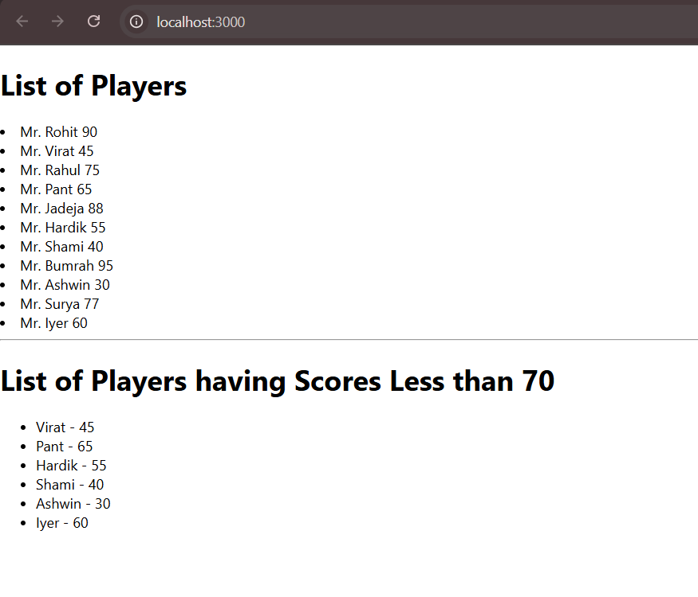

**When flag=false:**

